**PHASE I**

**Subject : Advanced Web Programming | Prof. : Mr Rajiv Gupta**

**Vrishti Shah (N078) | Sneha Kumari (N090) | Simar Ubhi (N101)**

**Table of Content**

1. Introduction to the Project

2. Problem Statement

3. Objectives

4. Scope of the Project

5. Technologies Used

6. Expected Outcome

7. ER DIAGRAM

8.Conclusion

## 1. Introduction to the Project

The **House & Hostel Rental System with Expense Tracking** is a web application designed to simplify property rentals and help users manage their regular expenses. The platform serves as a bridge between landlords and tenants, allowing them to post, search, book, and manage houses or hostel rooms efficiently.  
In addition to the rental system, the app includes an **Expense Tracker** feature, enabling users to log daily or monthly expenses (e.g., rent, utilities, food, transportation) and get detailed insights into their spending habits.

The system is intended to replace the conventional, time-consuming, and paper-based rental search process with an automated, secure, and user-friendly solution.

## 2. Problem Statement

Finding suitable rental properties and managing associated expenses can be challenging for students, professionals, and families. Common issues include:

* Difficulty in finding verified properties and reliable landlords.
* Lack of centralized platforms to manage bookings and rental payments.
* Manual tracking of monthly expenses, which often leads to mismanagement of finances.
* Limited communication between property owners and tenants.
* Absence of detailed cost analysis for accommodation-related expenses.

This project aims to solve these problems by providing a **centralized digital platform** where users can search, book, and manage rental properties, while also tracking their day-to-day expenses in a single application.

## 3. Objectives

1. The main objectives of the project are:
2. To design a user-friendly rental management platform for houses and hostels.
3. To enable landlords to list their properties with complete details, images, and availability status.
4. To allow tenants to search and filter properties based on location, type, price, and amenities.
5. To integrate a secure booking and payment management system.
6. To provide an **Expense Tracking** module for users to record and analyze regular expenses.
7. To generate expense reports and summaries for better financial management.
8. To ensure data security, privacy, and smooth communication between landlords and tenants.

## 4. Scope of the Project

The scope of the project includes:

* **Property Management:** Adding, updating, and deleting property listings.
* **Room Management:** Handling availability and pricing for houses and hostel rooms.
* **Search & Filter:** Enabling users to find properties based on specific preferences.
* **Booking System:** Allowing tenants to book rooms and pay online.
* **Payment Tracking:** Recording all transactions and payment statuses.
* **Expense Tracker:** Logging daily/weekly/monthly expenses, categorized for easy analysis.
* **Multi-role Support:** Separate dashboards for landlords and tenants.
* **Reports & Analytics:** Monthly expense charts, booking history, and payment records.
* **Responsive Design:** Accessible from desktop, tablet, and mobile devices.

## 5. Technologies Used

* **Frontend:** HTML5, CSS3, Typescript, Angular, Bootstrap
* **Backend:** Node.js
* **Database:** MySQL
* **Web Server:** Apache / Custom Node.js HTTP server
* **Hosting (Optional):** AWS / Docker
* **Other Tools:**
  + Figma (UI/UX design)
  + Git/GitHub (Version control)
  + Postman (API testing)

## 6. Expected Outcome

By implementing this project, we expect to achieve:

1. A fully functional rental management system for houses and hostels.
2. A smooth, secure booking and payment experience for users.
3. A reliable platform for landlords to showcase properties and manage bookings.
4. An **integrated expense tracking module** to help users plan and monitor their spending.
5. Improved transparency and trust between landlords and tenants.
6. A centralized solution that reduces the time, effort, and cost involved in managing rentals and expenses.

## **7.** **ER DIAGRAM**

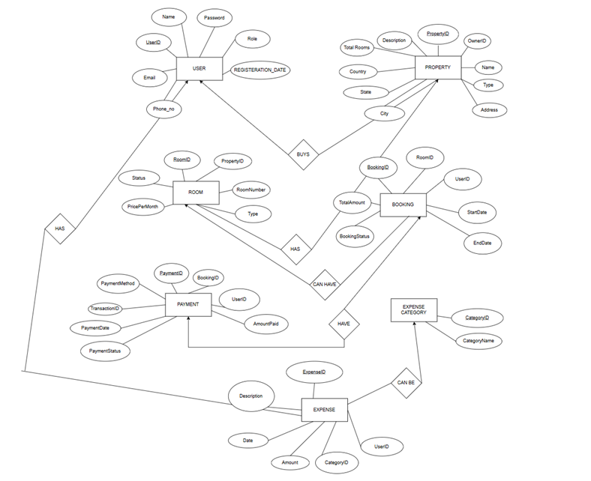

## 8.Conclusion

The House & Hostel Rental System with Expense Tracking offers a comprehensive solution for both property management and personal finance tracking. By combining rental booking features with expense management tools, the application streamlines the process of finding accommodation, making payments, and maintaining financial records. It reduces the dependency on traditional methods, improves transparency between landlords and tenants, and helps users stay organized with their monthly budgets.

With its user-friendly interface, secure database management, and real-time updates, the system is expected to enhance convenience, save time, and provide a modern, centralized platform that caters to the needs of students, professionals, and families alike.